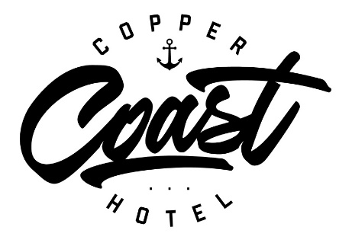

Dine in our Bistro bar, Beer garden
or
Take Home

Starters, Snacks & Smaller meals
Small/large
Garlic Bread
Garlicky, herby butter Ciabatta topped with grilled cheese. 6

Sweet Potato Chips 8
Deep fried and served with Sour Cream & Sweet Chili

Seasoned Wedges with Sour Cream & Sweet Chili 8

Bacon & Egg Burger with chips 12

Seafood

Fish and Chips in our own Southern Ale Batter 1 piece or 2 12/18
Boneless Butterfish served with chips, house made tartare and a side salad.

Local Whiting and Calamari Combo with salad, chips and tartare 16
Crumbed Calamari
Golden house cut & crumbed or dipped in our salt & pepper mix, served with chips, 18
house made tartare and a side salad.

Garlic Prawns OR Chili Coconut Prawns 6 or 12 16/27
Succulent prawns served in our house made sauces on a bed of rice.

Seafood Marinara 22
Prawns and Calamari served in a tomato spaghetti sauce

Burgers and Schnitzels

CC’s Beef, Chicken or Fish Burger – Famous in Wallaroo 18
Toasted Brioche bun, beef patty, egg, bacon, lettuce, caramalised onion,
cheese with our own mayo and tomato relish, stacked high and served with onion rings and chips.

Beef or Chicken Schnitzel ½ Schnitzel 12 Full 18
Served with chips, gravy (free) or topping (of your choice) and side salad.

Gravy - Complimentary
Extra $2 – Dianne - Pepper – Mushroom, Creamy Garlic
Extra $4 - Parmigiana - Meat Lovers Parmigiana – Kilpatrick
Extra $5 – Benedict - Bacon & Egg with Hollandaise
Extra $8 – Creamy Seafood Garlic Sauce with Calamari & Prawns

Steaks, Grills & Roast

Rump Steak
Traditional tried and fried Tender rump beef with gravy 180g 16 - 350g 28
served with chips or mash and a side salad. Even better with a nice glass of red.

Bacon & Eggs Big Breakfast 18
Big Breakfast with all the trimmings any time…why not

Roast of the Day – Available only some days. Ask your server 16

Kids Meals - with a Free small soft drink 10

Bangers and Mash
Chicken Schnitzel with chips & Gravy
Spaghetti Napolitano with cheese
Popcorn Chicken with chips
1 Piece of Fish and Chips

EXTRAS & Sides

Bowl of chips GF 5
Fried egg 3
Mixed Leaf Salad V 4
Steamed Vegies V 4

Specialty Tap Beers brewed by our own brewery Schooner Pint

Southern Ocean Pale Ale 5 7
Ryesby English Ale 5 7
Australian Lager 5 7

Ask your server for a tempting taste of our own beers and only available in SA here!

White Wine Glass Bottle

Stoneleigh NZ Sauvignon Blanc 750ml 6 22
Eaglehawk Sauvignon Blanc 750ml 20

Angove Moscato - 187ml 5.5
Angove Chardonnay - 187ml 5.5
Angove Sauvignon Blanc - 187ml 5.5
Jacobs Creek Sauvignon Blanc 187ml 6

Red Wine

Angove Shiraz 187ml 5.5
Angove Merlot 187ml 5.5
Jacobs Creek Cabernet Sauvignon 187ml 6
Grant Burge Cabernet Sauvignon 187ml 8

